**Running Collection remotely with URL:**

First open the postman and click on the three dots on the collection and select the option as share.

And click on Via API and a Api got generated and copy that Api.

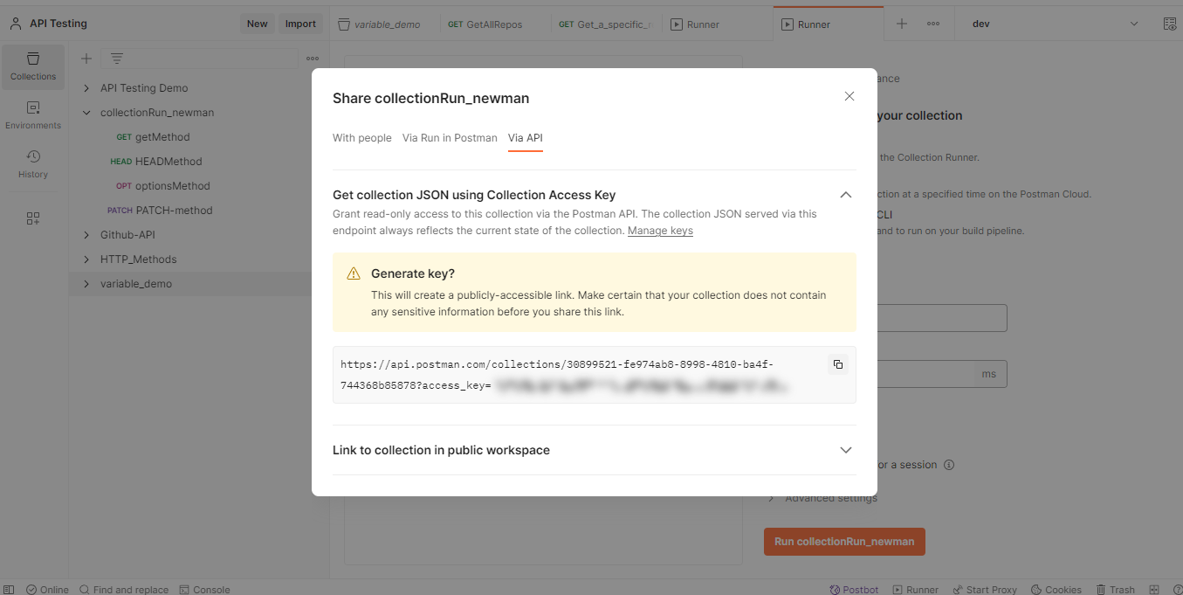

Now open the command prompt and execute the below command

# newman run <Copied URL>

And executes as given below.

